**Experiment 1:**

For financial dataset:

**Model 1: Simple RNN**

_________________________________________________________________

Layer (type) Output Shape Param #

=================================================================

embedding_13 (Embedding) (None, 1000, 32) 205120

_________________________________________________________________

simple_rnn_18 (SimpleRNN) (None, 32) 2080

_________________________________________________________________

dense_11 (Dense) (None, 3) 99

=================================================================

Total params: 207,299

Trainable params: 207,299

Non-trainable params: 0

_________________________________________________________________

**Results After 20 Epochs:**

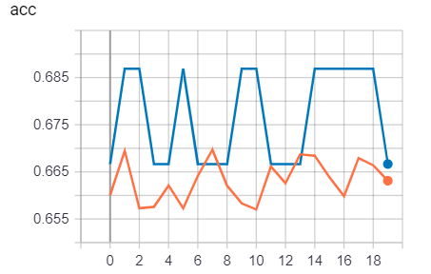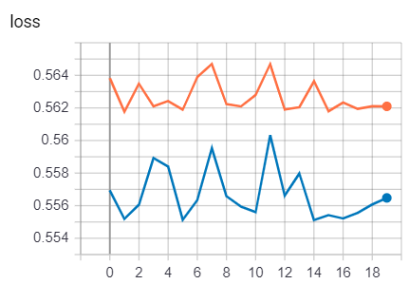

**Model 2: 2 layer Simple RNN**

Layer (type) Output Shape Param #

=================================================================

embedding_14 (Embedding) (None, 1000, 32) 205120

_________________________________________________________________

simple_rnn_19 (SimpleRNN) (None, 1000, 32) 2080

_________________________________________________________________

simple_rnn_20 (SimpleRNN) (None, 32) 2080

_________________________________________________________________

dense_12 (Dense) (None, 3) 99

=================================================================

Total params: 209,379

Trainable params: 209,379

Non-trainable params: 0

_________________________________________________________________

**(more in Notebook)**

**Model 3: SIngle layer Simple LSTM**

Layer (type) Output Shape Param #

=================================================================

embedding_3 (Embedding) (None, 1000, 32) 205120

_________________________________________________________________

lstm_2 (LSTM) (None, 32) 8320

_________________________________________________________________

dense_3 (Dense) (None, 3) 99

=================================================================

Total params: 213,539

Trainable params: 213,539

Non-trainable params: 0

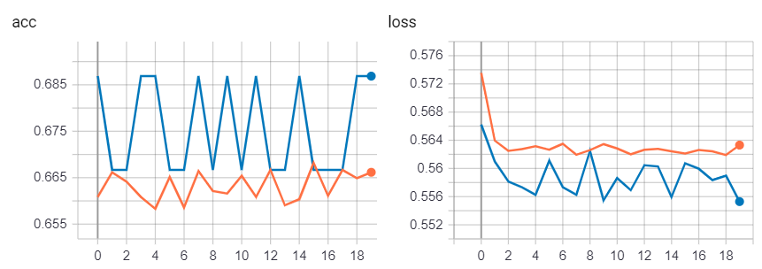

Confusion Matrix:

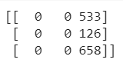

Same for all the model build with rnn. This can be because most of the cases are of same class.

How to improve model?

1. Need more preprocessing and valid data.
2. Need to perform some smoothing techniques.